Factors Associated with Polycystic Ovary Syndrome (PCOS): An Analytical Cross-Sectional Study

Abstract
Background. Polycystic ovary syndrome (PCOS) affects many young women, yet it is often noticed late. We looked at which personal, lifestyle and family characteristics go along with a PCOS diagnosis in a sample of young women.
Methods. In this analytical cross-sectional study, 249 women completed a structured questionnaire; 82 (32.9%) reported PCOS. We compared groups with unadjusted odds ratios (OR) and then fitted one logistic regression using ten variables chosen in advance: age, BMI, family history, other medical conditions, sleep, stress, exercise, junk food, smoking or alcohol, and anxiety or depression. Symptoms that overlap with the PCOS definition, such as irregular periods and hair growth, were analysed separately. Performance was checked by bootstrap (1,000 resamples).
Results. Median age was 20 years (IQR 19 to 21). After adjustment, family history of PCOS (adjusted OR 8.35, 95% CI 3.94 to 17.67), high stress (2.34, 1.16 to 4.73) and sleeping 7 to 8 hours (0.24, 0.12 to 0.47) were associated with PCOS. BMI showed a weaker association (1.06 per kg/m², 0.98 to 1.15) and age showed none. The model discriminated modestly: the C-statistic was 0.79 as fitted and 0.75 after correcting for optimism. Adding symptoms raised it to 0.86, which mostly reflects the overlap with diagnostic features.
Conclusion. A family history of PCOS, high stress and shorter sleep were associated with PCOS, while lifestyle habits such as exercise, diet and smoking were not clearly related. This design cannot show cause or direction, and the model is not suitable for screening.
Keywords: polycystic ovary syndrome; cross-sectional studies; family history; sleep; stress; body mass index

1. Introduction
PCOS is one of the commonest hormonal conditions in women of reproductive age. It is defined by irregular or absent ovulation, signs of raised androgens and, on ultrasound, polycystic-looking ovaries, and it is linked to weight gain, insulin resistance and mood problems [1,2]. In India the condition is usually called PCOD in everyday speech; we use PCOS throughout.
Most survey studies of PCOS ask women about symptoms and then test how well the symptoms separate cases from non-cases. That approach has a built-in problem. Missed periods and excess hair growth are part of how PCOS is diagnosed, so finding that they "predict" PCOS says very little. A more useful question is whether things that exist independently of the diagnosis, such as body weight, family history and daily habits, differ between women with and without PCOS.
We therefore set out to assess the demographic, anthropometric, lifestyle and clinical factors associated with PCOS in our sample. Symptoms that overlap with the diagnosis are described but kept out of the main analysis.

2. Methods

2.1 Design and participants
This was an analytical cross-sectional study, reported following the STROBE checklist [3]. Data came from 249 women who completed a structured questionnaire on body measurements, lifestyle, family and medical history and symptoms Every woman in the dataset was included.

2.2 Outcome
The outcome was PCOS (yes or no) as recorded in the questionnaire. Of the 249 women, 82 were in the PCOS group and 167 in the comparison group.

2.3 Variables
Before any modelling, the 30 questionnaire variables were sorted into three groups on clinical grounds. Only group A entered the main model.
Group | Variables | How they were used
A. Independent factors | Age, BMI, family history, other medical condition, sleep (7 to 8 h), stress, exercise, junk food, smoking or alcohol, anxiety or depression | Compared between groups and entered in the main model
B. Diagnostic or symptom features | Irregular periods, cycle length, period length, heavy bleeding, period pain, hair growth (six sites), acne, dark patches, sudden weight change, mood swings, tiredness | Described and compared. Not used as explanatory factors, because they overlap with how PCOS is diagnosed or may follow from it
C. Not analysed | Serial number, height and weight (covered by BMI), weight status (derived from BMI) | Left out to avoid duplication
Age and BMI were kept continuous. BMI was recalculated from height and weight and matched the recorded value in every complete record. Reference categories were: family history, medical condition, sleep, smoking or alcohol, and anxiety or depression, "no"; exercise, "never". Two categories were too small to stand alone, so stress was coded high versus low or moderate (only 13 women reported low stress) and junk food as daily versus never or often (only 15 women reported never). Smoking and alcohol were asked as one combined question, so they are analysed as one variable.

2.4 Missing data
One woman, who had PCOS, had no recorded weight, and her BMI had been entered as 0. We treated the BMI as missing instead of replacing it with the group mean. The main model therefore uses 248 women (81 with PCOS). As a check, we repeated it with weight imputed 20 times from height, age and PCOS status, pooling results by Rubin's rules.

2.5 Statistical analysis
Continuous variables are given as median and interquartile range and compared with the Mann–Whitney test. Categorical variables are given as number and percentage and compared with the chi-square test, or Fisher's exact test when an expected count was below 5. Each comparison also reports an unadjusted odds ratio with a 95% confidence interval. We did not use a normality test to choose methods.
The main model was a single logistic regression containing all group A variables, with no stepwise selection. It has 11 parameters for 81 events, about 7 events per parameter. We report adjusted odds ratios with 95% CIs for all of them, a Hosmer–Lemeshow test, Nagelkerke R², and the largest variance inflation factor. Discrimination is given as the C-statistic (area under the ROC curve). Because that figure is optimistic when measured on the data used to build the model, we also report an optimism-corrected value and calibration slope from 1,000 bootstrap resamples [4].
A second model added four group B items (irregular periods, upper-lip hair growth, mood swings, dark patches) to show how much discrimination depends on diagnostic overlap. It is descriptive only. For the 15 group B comparisons we also give Benjamini–Hochberg adjusted p-values. All tests were two-sided with α = 0.05, and analyses were run R and Python

3. Results

3.1 Who was in the sample
The 249 women were young: median age 20 years, and 231 (93%) were between 18 and 22. Eighty-two (32.9%) were in the PCOS group. Table 1 compares the two groups on the independent factors. Women with PCOS were more likely to report a family history of PCOS (41.5% against 12.6%), less likely to report 7 to 8 hours of sleep (43.9% against 71.3%) and more likely to report high stress (42.7% against 25.7%). Their median BMI was about 1.7 kg/m² higher (22.7 against 21.0). Age, exercise, junk food, smoking or alcohol, other medical conditions and anxiety or depression did not differ clearly between groups. Weight followed the same pattern as BMI (unadjusted p = 0.002).

Table 1. Independent factors by PCOS status
Characteristic | PCOS (n = 82) | No PCOS (n = 167) | Unadjusted OR (95% CI) | p
Age, years, median (IQR) | 20.0 (19.2 to 21.0) | 20.0 (19.0 to 21.0) | 0.96 (0.83 to 1.12) per year | 0.904
BMI, kg/m², median (IQR) ¹ | 22.7 (20.2 to 25.4) | 21.0 (19.0 to 24.2) | 1.08 (1.01 to 1.15) per unit | 0.014
Family history of PCOS, n (%) | 34 (41.5) | 21 (12.6) | 4.92 (2.61 to 9.29) | <0.001
Sleeps 7 to 8 hours, n (%) | 36 (43.9) | 119 (71.3) | 0.32 (0.18 to 0.55) | <0.001
Stress level, n (%) |  |  |  | 0.016
Low | 2 (2.4) | 11 (6.6) | 1 (reference)
Moderate | 45 (54.9) | 113 (67.7) | 2.19 (0.47 to 10.28)
High | 35 (42.7) | 43 (25.7) | 4.48 (0.93 to 21.55)
Exercise, n (%) |  |  |  | 0.910
Never | 34 (41.5) | 74 (44.3) | 1 (reference)
Often | 40 (48.8) | 78 (46.7) | 1.12 (0.64 to 1.95)
Daily | 8 (9.8) | 15 (9.0) | 1.16 (0.45 to 3.00)
Junk or fast food, n (%) |  |  |  | 0.540
Never | 4 (4.9) | 11 (6.6) | 1 (reference)
Often | 69 (84.1) | 144 (86.2) | 1.32 (0.40 to 4.29)
Daily | 9 (11.0) | 12 (7.2) | 2.06 (0.49 to 8.65)
Smoking or alcohol, n (%) | 10 (12.2) | 15 (9.0) | 1.41 (0.60 to 3.29) | 0.428
Other medical condition, n (%) | 17 (20.7) | 22 (13.2) | 1.72 (0.86 to 3.46) | 0.123
Anxiety or depression, n (%) | 30 (36.6) | 45 (26.9) | 1.56 (0.89 to 2.75) | 0.119
¹ BMI available for 81 women with PCOS and 167 without. Continuous variables were compared with the Mann–Whitney test; the odds ratio is per one-unit increase from a single-variable logistic regression. Categorical variables used the chi-square test; for yes/no items the odds ratio compares yes with no.

3.2 What stays associated after adjustment
When all ten independent factors were entered together (248 women, 81 with PCOS), three remained clearly associated with PCOS: family history, sleep and stress. Family history showed the largest association. Women reporting a family history of PCOS had about eight times the odds of PCOS, and the estimate got larger after adjustment (5.0 before, 8.3 after). Sleeping 7 to 8 hours was linked to roughly a quarter of the odds, and high stress to more than double.
BMI was associated with PCOS on its own (OR 1.08 per unit) but the association weakened and became imprecise once the other factors were included (adjusted OR 1.06, 95% CI 0.98 to 1.15). Age, exercise, junk food, smoking or alcohol, other medical conditions and anxiety or depression showed no clear association, though several of these intervals are wide and a modest effect cannot be ruled out.
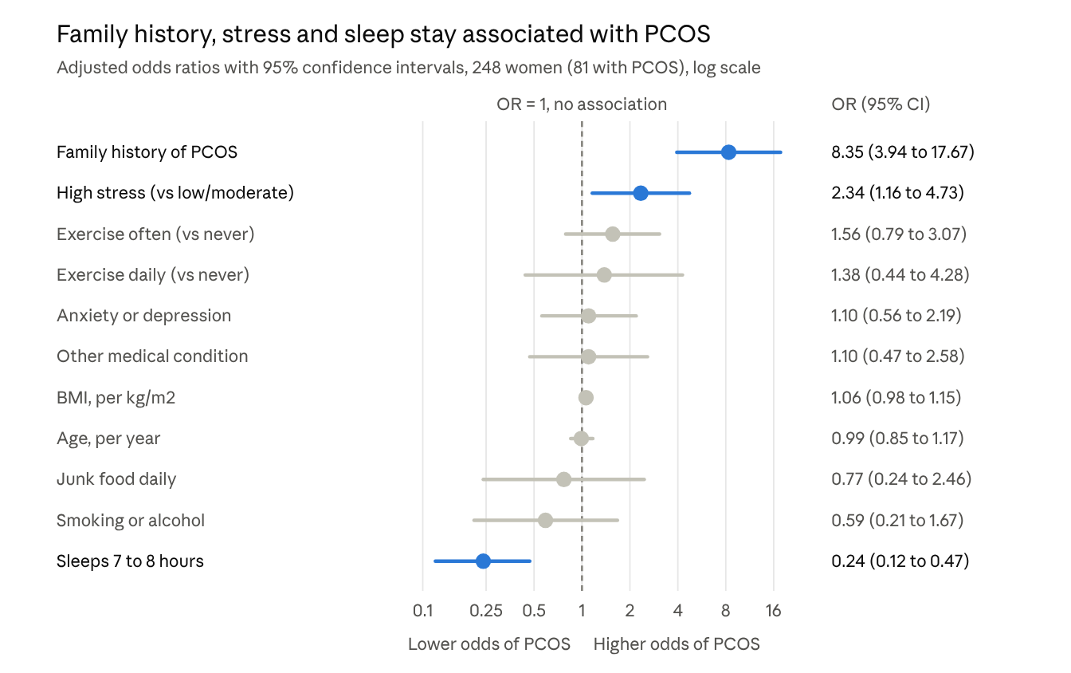
Adjusted logistic regression, 10 pre-specified factors; blue marks have intervals that exclude 1
Table 2. Unadjusted and adjusted odds ratios for PCOS (n = 248, events = 81)
Factor | Unadjusted OR (95% CI) | Adjusted OR (95% CI) | p (adjusted)
Age, per year | 0.96 (0.82 to 1.12) | 0.99 (0.85 to 1.17) | 0.945
BMI, per kg/m² | 1.08 (1.01 to 1.15) | 1.06 (0.98 to 1.15) | 0.131
Family history of PCOS | 5.03 (2.66 to 9.50) | 8.35 (3.94 to 17.67) | <0.001
Other medical condition | 1.62 (0.80 to 3.29) | 1.10 (0.47 to 2.58) | 0.828
Sleeps 7 to 8 hours | 0.32 (0.19 to 0.56) | 0.24 (0.12 to 0.47) | <0.001
High stress (vs low or moderate) | 2.09 (1.19 to 3.66) | 2.34 (1.16 to 4.73) | 0.017
Exercise often (vs never) | 1.06 (0.62 to 1.80) | 1.56 (0.79 to 3.07) | 0.202
Exercise daily (vs never) | 1.11 (0.45 to 2.74) | 1.38 (0.44 to 4.28) | 0.579
Junk food daily (vs never or often) | 1.42 (0.55 to 3.61) | 0.77 (0.24 to 2.46) | 0.659
Smoking or alcohol | 1.27 (0.53 to 3.03) | 0.59 (0.21 to 1.67) | 0.320
Anxiety or depression | 1.51 (0.86 to 2.67) | 1.10 (0.56 to 2.19) | 0.776
Checks. Pooling 20 imputations that included the woman with missing weight gave almost the same results (family history 8.19, 3.87 to 17.34; sleep 0.24, 0.12 to 0.47; high stress 2.34, 1.16 to 4.72). The model showed no collinearity problem (largest VIF 1.22). A squared age term was statistically significant (p = 0.028), but this came from a single 37-year-old; dropping the three women older than 25 left the main findings unchanged (family history 8.54, 4.00 to 18.25; sleep 0.22, 0.11 to 0.43; high stress 2.31, 1.14 to 4.66). A squared BMI term added nothing (p = 0.73), so BMI was kept linear.

3.3 How well the model separates the groups
The main model separates women with and without PCOS only modestly. Its C-statistic was 0.79 on the data used to fit it, and 0.75 after correcting for optimism. The calibration slope of 0.80 means the fitted coefficients are about a fifth too extreme and would shrink in new data. Calibration across risk deciles was acceptable (Hosmer–Lemeshow p = 0.315).
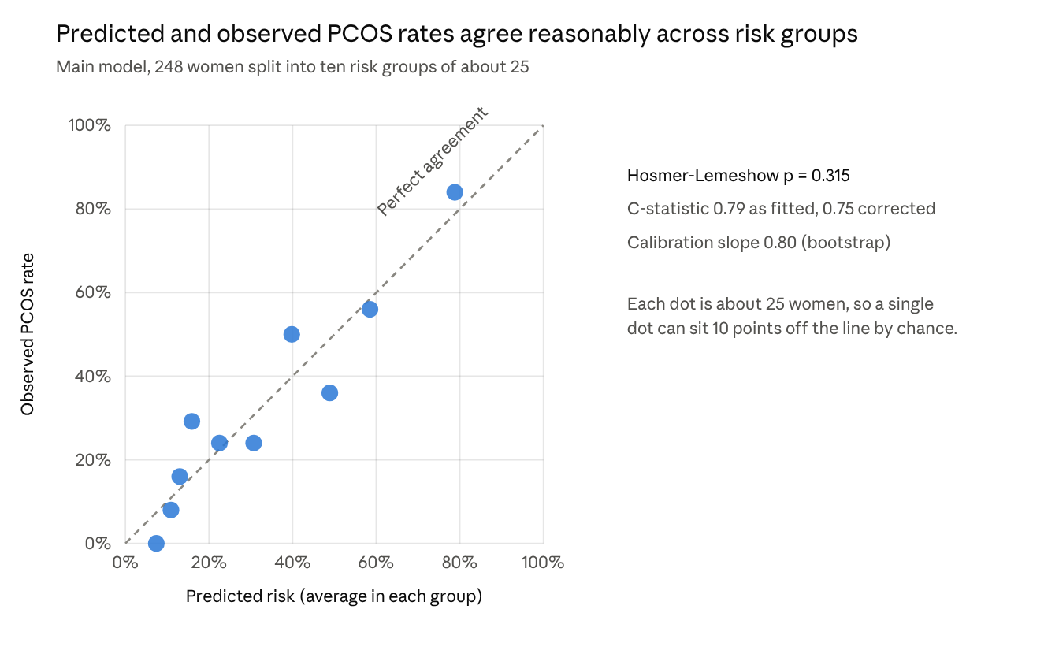
Predicted risk from the main model against observed PCOS rate, by tenth of predicted risk
Adding four symptom variables lifted the C-statistic to 0.89 (0.86 corrected). Almost all of that gain comes from irregular periods (adjusted OR 13.6, 95% CI 6.1 to 30.4), with smaller contributions from upper-lip hair growth (2.76, 1.13 to 6.74) and mood swings (4.04, 1.07 to 15.31). Because these are diagnostic features, the jump shows overlap with the definition of PCOS and says little about prediction. In that model family history (6.28, 2.55 to 15.48) and sleep (0.23, 0.10 to 0.53) kept their associations, while high stress fell to 2.02 (0.87 to 4.67). One new finding, exercising often (2.41, 1.02 to 5.71), was not seen in the main model and is probably chance given 15 predictors and 81 events.
Table 3. Model performance
Measure | Main model (group A) | With symptoms (descriptive)
Parameters | 11 | 15
C-statistic, as fitted | 0.789 | 0.894
C-statistic, optimism-corrected | 0.747 | 0.861
Calibration slope (bootstrap) | 0.80 | 0.79
Nagelkerke R² | 0.30 | 0.56
Hosmer–Lemeshow p | 0.315 | 0.131
Brier score | 0.169 | 0.112
Largest VIF | 1.22 | 1.27

3.4 Symptoms and clinical features
Most group B features were more common in the PCOS group (Table 4). The largest differences were for irregular or missed periods (80.5% against 24.0%), mood swings (95.1% against 76.6%), upper-lip hair growth (85.4% against 58.7%), a variable cycle length (59.8% against 29.3%) and sudden weight change (54.9% against 25.7%). After Benjamini–Hochberg adjustment, 8 of the 15 comparisons stayed below 0.05: irregular periods, variable cycle, sudden weight change, mood swings, tiredness, dark patches and upper-lip and facial hair growth. Heavy bleeding, period pain, acne, hair thinning and hair growth on the arms showed no clear difference. Typical cycle length among women who gave a number was 28 days in both groups, and period length was 5 days in both (unadjusted OR 1.25 per day, 1.02 to 1.52, p = 0.052).
These features overlap with the diagnostic criteria, so we describe them here and do not treat them as explanatory factors.

Table 4. Group B features by PCOS status
Feature | PCOS, n (%) (n = 82) | No PCOS, n (%) (n = 167) | Unadjusted OR (95% CI) | p | Adjusted p (BH)
Irregular or missed periods | 66 (80.5) | 40 (24.0) | 13.10 (6.83 to 25.13) | <0.001 | <0.001
Mood swings | 78 (95.1) | 128 (76.6) | 5.94 (2.04 to 17.27) | <0.001 | 0.001
Upper-lip hair growth ¹ | 70 (85.4) | 98 (58.7) | 4.11 (2.07 to 8.15) | <0.001 | <0.001
Cycle length varies | 49 (59.8) | 49 (29.3) | 3.58 (2.06 to 6.22) | <0.001 | <0.001
Sudden weight gain or loss | 45 (54.9) | 43 (25.7) | 3.51 (2.01 to 6.12) | <0.001 | <0.001
Always tired | 48 (58.5) | 66 (39.5) | 2.16 (1.26 to 3.70) | 0.005 | 0.012
Facial hair growth ¹ | 54 (65.9) | 84 (50.3) | 1.91 (1.10 to 3.30) | 0.020 | 0.038
Dark skin patches | 40 (48.8) | 55 (32.9) | 1.94 (1.13 to 3.33) | 0.016 | 0.033
Hair on inner thighs ¹ | 56 (68.3) | 92 (55.1) | 1.76 (1.01 to 3.06) | 0.046 | 0.077
Acne or skin tags | 43 (52.4) | 68 (40.7) | 1.61 (0.94 to 2.73) | 0.080 | 0.117
Hair between breasts ¹ | 30 (36.6) | 44 (26.3) | 1.61 (0.92 to 2.84) | 0.097 | 0.121
Heavy bleeding | 47 (57.3) | 81 (48.5) | 1.43 (0.84 to 2.43) | 0.191 | 0.220
Hair growth on arms ¹ | 76 (92.7) | 142 (85.0) | 2.23 (0.88 to 5.67) | 0.086 | 0.117
Hair thinning or loss ¹ | 78 (95.1) | 156 (93.4) | 1.38 (0.42 to 4.46) | 0.779 | 0.779
Severe period pain | 50 (61.0) | 95 (56.9) | 1.18 (0.69 to 2.03) | 0.539 | 0.577
¹ Moderate or excessive growth or loss compared with never.

4. Discussion
In this sample of young women, a family history of PCOS, high stress and shorter sleep were each associated with PCOS, and these associations held after accounting for age, BMI and the other factors. Habits that are often blamed for PCOS, namely exercise, junk food and smoking or alcohol, showed no clear relationship in our data.
Family history was the strongest association (adjusted OR 8.35). That fits the familial clustering of PCOS that is well described in the literature [1,2]. It is also an easy item to ask about, which makes it worth recording in any clinic or campus health check. Because relatives were reported by the women themselves, some under-reporting among controls is possible, and that would push the estimate upward.
The sleep and stress findings need careful reading. Women with PCOS may sleep badly because of the condition or its symptoms, and they may feel more stressed because they are dealing with a diagnosis. Both could also be a consequence of weight, mood or other things we did not measure. All we can say is that these factors go together with PCOS in this sample. We cannot say which comes first.
BMI behaved differently. Women with PCOS had higher BMI on its own (OR 1.08 per unit), but the adjusted estimate was smaller and its interval included 1 (1.06, 0.98 to 1.15). With 81 events we cannot separate a small independent effect of BMI from the overlap with stress and sleep, so the right conclusion is "not clearly independent" and not "no effect". Age showed no association, though the sample was narrow: 93% of the women were 18 to 22, so we say nothing about older women.
The symptom results behave as expected. Missed periods, hair growth and weight change are used to diagnose PCOS, and they separated the groups sharply. Their association with the outcome is therefore close to built-in, which is why we left them out of the main model. The jump in C-statistic from 0.75 to 0.86 when four of them were added shows how much a symptom-based model would owe to the definition itself.

Strengths and limitations
We separated independent factors from diagnostic features before modelling, avoided stepwise selection, kept age and BMI continuous, handled the one missing weight openly, and reported optimism-corrected performance with adjusted estimates and confidence intervals throughout. Several limits remain.
- The design is cross-sectional, so we can describe associations only. Direction and cause are unknown.
- Information was reported by participants and may include recall and misclassification error.
- The sample is small and young. With 81 events, wide intervals (for instance on exercise and junk food) mean modest effects could be missed, and the findings may not apply to older women or other settings [5].
- We could not adjust for factors that were not collected, such as family income, diet quality, hormone levels or ultrasound findings.
- Many comparisons were run, so single borderline results (exercise "often" in the symptom model, for example) should be treated as possible chance findings.
- The main model has a modest corrected C-statistic of 0.75 and should not be used to screen or diagnose.

5. Conclusion
In this cross-sectional study of 249 young women, a family history of PCOS, high stress and sleeping 7 to 8 hours were associated with PCOS after adjustment, and BMI was only weakly and imprecisely associated. Exercise, diet and smoking or alcohol were not clearly related. These results are hypotheses for larger studies with confirmed diagnoses and, ideally, follow-up over time. They do not support using the model for screening.

References
- Rotterdam ESHRE/ASRM-Sponsored PCOS Consensus Workshop Group. Revised 2003 consensus on diagnostic criteria and long-term health risks related to polycystic ovary syndrome (PCOS). Fertil Steril. 2004;81(1):19–25.
- Teede HJ, Tay CT, Laven JJE, et al. Recommendations from the 2023 international evidence-based guideline for the assessment and management of polycystic ovary syndrome. Hum Reprod. 2023;38(9):1655–1679.
- von Elm E, Altman DG, Egger M, et al. The Strengthening the Reporting of Observational Studies in Epidemiology (STROBE) statement: guidelines for reporting observational studies. Lancet. 2007;370(9596):1453–1457.
- Collins GS, Moons KGM, Dhiman P, et al. TRIPOD+AI statement: updated guidance for reporting clinical prediction models that use regression or machine learning methods. BMJ. 2024;385:e078378.
- Riley RD, Ensor J, Snell KIE, et al. Calculating the sample size required for developing a clinical prediction model. BMJ. 2020;368:m441.

